[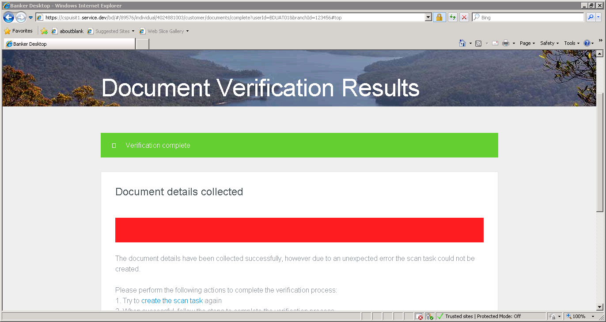](https://cspuisit1.service.dev/bd/#/89576/individual/4024881003/customer/documents/complete?userid=bduat01&branchid=123456#top)